An Unfinished Tale of Two Bubbles

What’s the common theme linking Cisco and Nvidia?

They’re both equipment suppliers to a new technology that’s going to change the world. And right now, like in 1998, everybody with half a brain can see that these new technologies are going to be huge. But, unfortunately, there are very few ways to play that glorious future that’s in the near future.

We all know the story of Levi Strauss & Co. during the California Gold Rush – the equipment suppliers that made money in that bubble.

And so we see Cisco and Nvidia today in a similar vein.

But once the technology starts to be used to actually change the world, other companies are major beneficiaries (like Amazon, Google etc.) and the equipment suppliers are correctly seen as commodity producers with low margins as competition seeps in.

And so it is today. Here’s a chart of Cisco vs Nvidia starting 18 months before the top of the tech bubble on a similar time and return scale.
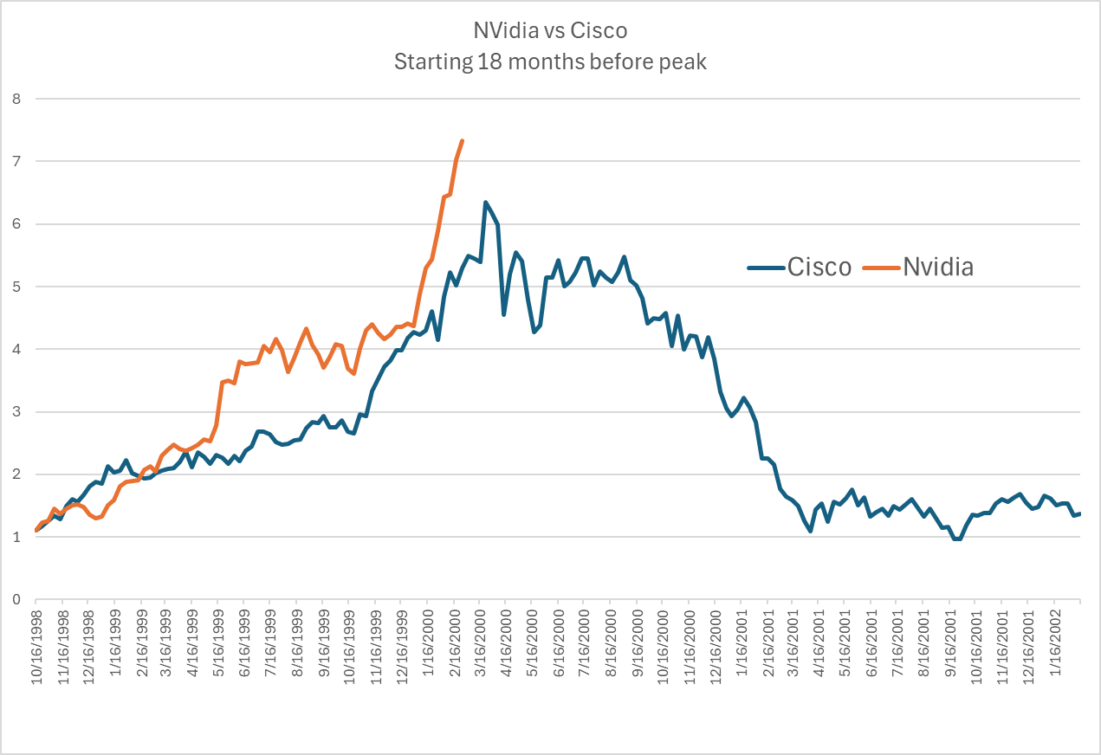
Are we now at the top for Nvidia? That’s unknowable.

As my colleague Jeremey Grantham likes to say, trying to figure out the top of a bubble is like charting the path of a feather in a hurricane. You have no idea as to how far or how high it will go. There is only one thing you know with certainty. It will hit the ground.

And so it was with Cisco…

If you bought it at the top - almost 25 years later, you’re still losing money.



So will Nvidia follow suit? Inevitably.

What I predict is that sometime in the next 12 months, we will see the peak. And you’re a fool if you think you can time that event exactly.

My advice is to sell 1/12th of your Nvidia holding now and another 1/12th every month for the next 12 months irrespective of what the stock does. That way, if I’m right that the top will be in the next 12 months, you will have got out near the top. And save yourself a bunch of sleepless nights.

